Date | 10 June 2009 OD29
Time (UT) | Activity |  | Signature
10:18 | AoS at 09:51  Temperatures now  PL0 – 1.711 K  Subktemp – 0.2871 K  Baftemp – 2.341 K  PT1000_T651 – baffle close to lid – 74.28 K |  | SDS/DKG
10:49 | Running procedure SETB – this switches HK rate from 4 sec to 1 sec  OBSID 0x0000206E
11:00 | Running modified procedure NSON with DPU boot TCs removed. It stops onboard monitoring, loads all the VM, monitoring and actions tables and then restarts monitoring.  OBSID 0x0000206D  The STOP_MONITORING TC failed with failure code 0x831 – Function is already stopped  Tables uploaded OK  The START_MONITORING TC produced a TM(5,1) event:  0x7002 5112 0000 206D 8000 0000 4423 A8E0 0000 88E0 F06B FFFF F06B 0000 0000  PUMPHTRTEMP N to F  No other events
11:17 | Running procedure MBSN – BSM_ON  OBSID 0x00002065  Switched to MG antenna
11:38 | Running procedure MBSI – BSM_INIT  OBSID 0x00002066
11:45 | Running procedure MPHN – PDET_ON  OBSID 0x00002067  Detectors switched on OK  Mode remains PDET_ON – check later why it is not PHOT_STBY.
11:59 | Running procedure PTCT – PTC PID Tuning with SUBKTEMP  Default PTC VM TPF on the MCS is HCSPTCTE_50976753_0002.IPF  OBSID 0x00002068  See a Random Telegraph Signal type jump of ~150ADU in PTC3 at ~11:54  Another RTS jump on PTC2 jump at ~11:59  Comment: First PTC Test of OD29 is to start the PTC VM on the nominal parameters as used during ILT. The set point is 150 dec. from quiescent SUBKTEMP.  PTCTCB Heater Switch on Step skipped but 5 minutes of wait time before setting of offsets  12:11 PTC VM running OK but no DCU science data after resetting of detector offsets  VM Science TM packets are not recognised by the HPSDSB.  SUBKTEMP looks very stable  Procedure Change Request Sheet #10 submitted to insert 0x843e0001 DRCU command to restart detector data  12:27: Detector data restarted  12:59: Halted VM1 and switched off the PTC heater.  End of first PTC test of OD29  Comment: The next test we turn on the PTC heater in open loop via the Send DRCU Command 0xA0C602BC, wait for a quasi stable temperature on the 300-mK system then switch on PTC to stabilise at this temperature. This is like a PTC restart.  Now wait for the SUBKTEMP to stablilise  13:18: Switch on PTC heater: 0xa0c602bc (Left the commanded value unchanged after analysis of VM science packets  Stopped DCU data and reset Photometer Offsets  Sent HCSPTCTE_50976753_0003.IPF to the MCS via FTS – in this version the Delta Reqd temperature is set to 0.  Wrapper file TPF__SPISDA_D_HCS_SPTCT_IPF_00003.HERS  13:33 PTC VM now running again with TPF 0003  SUBKTEMP very stable (within limits of the precision of the sensor)  OPTTEMP warming (i.e. FPU)  Detector box warming slowly (PL0)  PTC#2 cooling  PSW T1, PMW T1 and PLW T1 warming  13:44 - Stopped PTC VM but did not switch off the PTC heater  Comment: The third test of the day is to see if the performance improves with a low cut off frequency on the Low pass filter. Change from 2.0Hz Knee to 0.2Hz  Sent HCSPTCTE_50976753_0004.IPF to the MCS via FTS –  Delta Reqd temperature is still set to 0.  Gain is set to 74.85  B Coeff1 1.64746  B Coeff2 -0.709  PTC 1,2,3 all showing ~0.25Hz oscillations.  Wrapper file TPF__SPISDA_D_HCS_SPTCT_IPF_00004.HERS  13:52 PTC VM now running with TPF 0004  14:21 - Stopped PTC VM but did not switch off the PTC heater  Comment: The last test for the day (4th) before LOS is with the Kp and Kd reduced by a factor of 4 over the ILT values. There is not enough time to do a comprehensive test here…  Sent HCSPTCTE_50976753_0005.IPF to the MCS via FTS –  Same as TPF 003 but with  Kp is 7.5  Ki is 0.2  Wrapper file TPF__SPISDA_D_HCS_SPTCT_IPF_00005.HERS  14:25 PTC VM now running with TPF 0005  Under pressure from MCS to finish this test by 14:33! Could have done with 10 minutes more – DTCP LOS is at 14:53  14:33- Stopped PTC VM  DCU data stopped  PTC heater not switched off – the flow chart in PTCT is inconsistent with procedure  In the flowchart heater switch off is part of HCSPTCTE but in procedure it is in step HCSPTCTF
  HCSPTCTE_50976753_0002.IPF 2009-05-30T12:05:00Z
  Param number | Value (raw) | Desc. | Value | Comment
  1 | R FFFFFF6A | H Delta required temperature (ADC units) | 0x96 (150dec.) delta on the subktemp | Roughly 1uW
  2 | R A8F00000 | H PTC SUBKTEMP get temperature command
  3 | R 200000 | D PTC Loop period (us) |  | 5Hz
  4 | R 41F00000 | H Kp (PID parameter)- float | 30
  5 | R 3F4CCCCD | H Ki (PID parameter)- float | 0.8
  6 | R 3B23D70A | H Kd (PID parameter)- float | 0.0025
  7 | R 47435000 | H Ki limit - float | 50000
  8 | R 3FC8547F | H Low pass filter gain - float | 1.565 | Corresponds to a 2Hz filter knee
  9 | R BF924D2F | H Low pass filter coefficient b1 - float | -1.14298 | Corresponds to a 2Hz filter knee
  10 | R BED35ABB | H Low pass filter coefficient b2 - float | -0.4128 | Corresponds to a 2Hz filter knee
  11 | R 0 | D DAC constant offset - float
  12 | R 2048 | D Max DAC value - int
  13 | R 1 | D Pulse Width Modulation (PWM) flag
  14 | R 5 | D TM flag (# VM sci frames/VM TM Pkt)
  15 | R 100 | D Init count - try > 2
  16 | R 0 | D Error Compensation Parameter - float
  HCSPTCTE_50976753_0003.IPF 2009-06-11T10:30:00Z
  Param number | Value (raw) | Desc. | Value | Comment
  1 | R 00000000 | H Delta required temperature (ADC units) | Zero | Stabilize the subktemp at the current value
  2 | R A8F00000 | H PTC SUBKTEMP get temperature command
  3 | R 200000 | D PTC Loop period (us) |  | 5Hz
  4 | R 41F00000 | H Kp (PID parameter)- float | 30
  5 | R 3F4CCCCD | H Ki (PID parameter)- float | 0.8
  6 | R 3B23D70A | H Kd (PID parameter)- float | 0.0025
  7 | R 47435000 | H Ki limit - float | 50000
  8 | R 3FC8547F | H Low pass filter gain - float | 1.565 | Corresponds to a 2Hz filter knee
  9 | R BF924D2F | H Low pass filter coefficient b1 - float | -1.14298 | Corresponds to a 2Hz filter knee
  10 | R BED35ABB | H Low pass filter coefficient b2 - float | -0.4128 | Corresponds to a 2Hz filter knee
  11 | R 0 | D DAC constant offset - float
  12 | R 2048 | D Max DAC value - int
  13 | R 1 | D Pulse Width Modulation (PWM) flag
  14 | R 5 | D TM flag (# VM sci frames/VM TM Pkt)
  15 | R 100 | D Init count - try > 2
  16 | R 0 | D Error Compensation Parameter - float
  HCSPTCTE_50976753_0004.IPF 2009-06-11T11:05:00Z
  Param number | Value (raw) | Desc. | Value | Comment
  1 | R 00000000 | H Delta required temperature (ADC units) | Zero | Stabilize the subktemp at the current value
  2 | R A8F00000 | H PTC SUBKTEMP get temperature command
  3 | R 200000 | D PTC Loop period (us) |  | 5Hz
  4 | R 41F00000 | H Kp (PID parameter)- float | 30
  5 | R 3F4CCCCD | H Ki (PID parameter)- float | 0.8
  6 | R 3B23D70A | H Kd (PID parameter)- float | 0.0025
  7 | R 47435000 | H Ki limit - float | 50000
  8 | R 4295B5A6 | H Low pass filter gain - float | 74.85 | Corresponds to a 0.2Hz filter knee
  9 | R 3FD2DFF8 | H Low pass filter coefficient b1 - float | 1.64746 | Corresponds to a 0.2Hz filter knee
  10 | R BF336DF9 | H Low pass filter coefficient b2 - float | -0.700897 | Corresponds to a 0.2Hz filter knee
  11 | R 0 | D DAC constant offset - float
  12 | R 2048 | D Max DAC value - int
  13 | R 1 | D Pulse Width Modulation (PWM) flag
  14 | R 5 | D TM flag (# VM sci frames/VM TM Pkt)
  15 | R 100 | D Init count - try > 2
  16 | R 0 | D Error Compensation Parameter - float
  HCSPTCTE_50976753_0005.IPF 2009-06-11T14:12:00Z
  Param number | Value (raw) | Desc. | Value | Comment
  1 | R 00000000 | H Delta required temperature (ADC units) | Zero | Stabilize the subktemp at the current value
  2 | R A8F00000 | H PTC SUBKTEMP get temperature command
  3 | R 200000 | D PTC Loop period (us) |  | 5Hz
  4 | R 40F00000 | H Kp (PID parameter)- float | 7.5 | Reduced by a factor of four from ILT values
  5 | R 3E4CCCCD | H Ki (PID parameter)- float | 0.2 | Reduced by a factor of four from ILT values
  6 | R 3B23D70A | H Kd (PID parameter)- float | 0.0025
  7 | R 47435000 | H Ki limit - float | 50000
  8 | R 3FC8547F | H Low pass filter gain - float | 1.565 | Corresponds to a 2Hz filter knee
  9 | R BF924D2F | H Low pass filter coefficient b1 - float | -1.14298 | Corresponds to a 2Hz filter knee
  10 | R BED35ABB | H Low pass filter coefficient b2 - float | -0.4128 | Corresponds to a 2Hz filter knee
  11 | R 0 | D DAC constant offset - float
  12 | R 2048 | D Max DAC value - int
  13 | R 1 | D Pulse Width Modulation (PWM) flag
  14 | R 5 | D TM flag (# VM sci frames/VM TM Pkt)
  15 | R 100 | D Init count - try > 2
  16 | R 0 | D Error Compensation Parameter - float
Screenshots from PTC Tests:
- SUBKTEMP (Raw and Converted), TCHTRV and PSW-T1 and 2) Central bolometers from each array
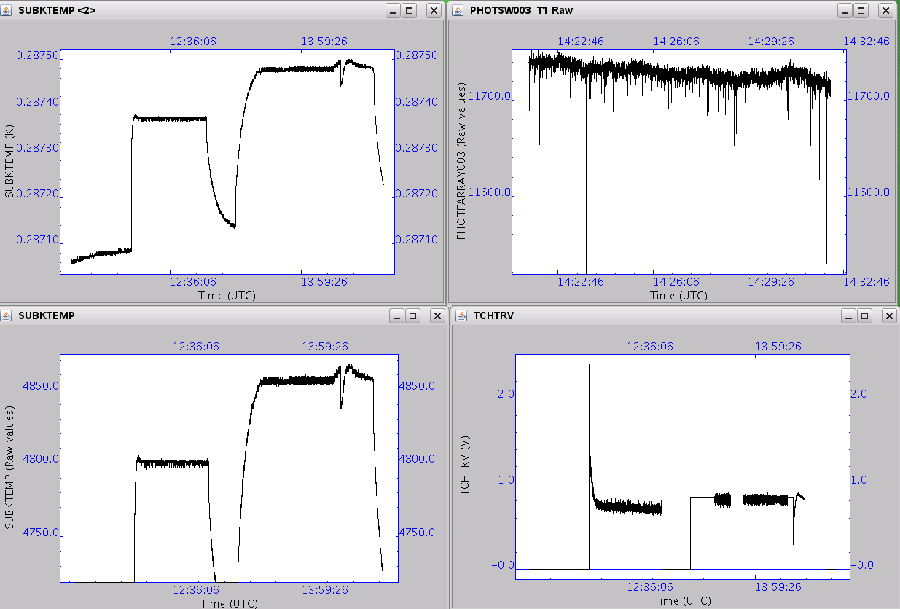
 | 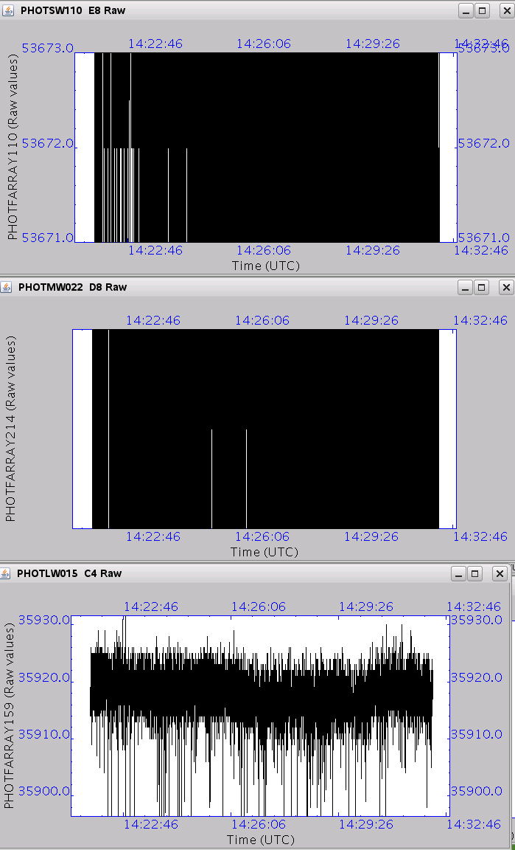
14:36 | PDET_OFF  0x00002069
14:41 | BSM_OFF  0x0000206A  14:46 PTC heater switched off by manually inserting the 0xa0c60000 TC  Back in REDY mode.

